**Assignment -2**

Python Programming

|  |  |
| --- | --- |
| Assignment Date | 17 October 2022 |
| Student Name | R. Brigita Magrin Abishag |
| Student Roll Number | 194033 |
| Maximum Marks | 2 Marks |

**Question-1:**

Write a flask program which should display Name,Email,phone and it should display the same details once we hit submit.

**Solution:**

**HTML CODE**

<html>

<body>

<form action="/login" method = "post">

<p> Name: </p>

<p><input type = "text" name = "nm"/></p>

<p> E-mail: </p>

<p><input type = "text" email = "email"/><p>

<p> Phone-no: </p>

<p><input type = "tel" phone-no = "phn"/><p>

<p> <input type = "submit" value = "submit"/></p>

</form>

<b> {{y}} </b>

</body>

</html>

**FLASK PROGRAM**

from flask import Flask,render_template,request

app=Flask(_name_)

@app.route('/')

def home():

return render_template('index.html')

@app.route('/login' , methods = ["POST"])

def login():

if request.method == "POST":

user = request.form["nm"]

return render_template("index.html",y = user)

if _name_ =='_main_':

app.run(debug=True)

**OUTPUT:**

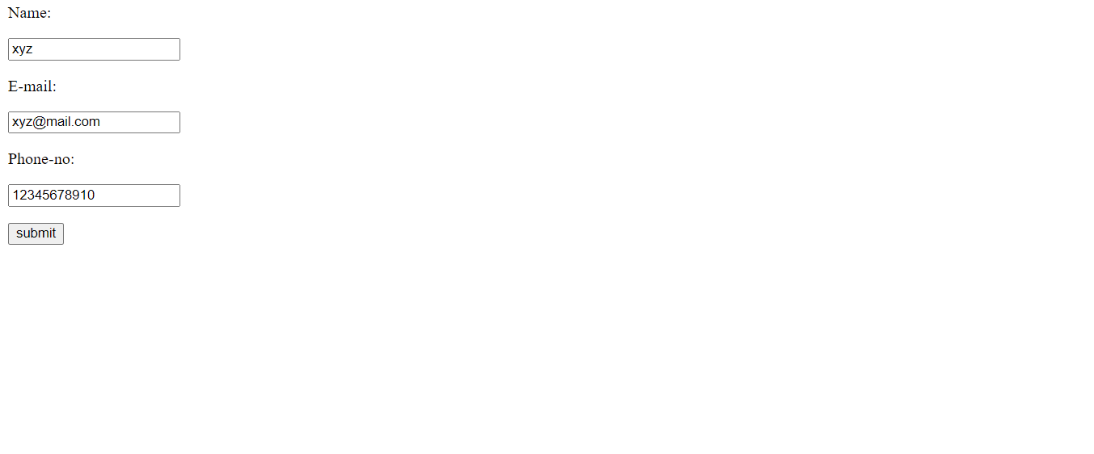

**Question-2:**

Write a flask program which should cover cookies,sessions.

**SOLUTION:**

**FLASK PRROGRAM**

from flask import render_template, make_response, request,Flask, redirect, url_for, session

import os

app=Flask(_name_)

app.secret_key=os.urandom(24)# this is an important step

#flask will not allow you to use cookies without a secret key

@app.route('/',methods=['GET','POST'])

def index():

if not(session.get('user')):

if not request.cookies.get('choice'):

if request.method=='POST':

colour=str(requestform['color'])

response=make_response("Setting your Cookie and Session! Please refresh the page to see the results -")

response.set_cookie('choice',colour)

session['user']=str(request.form['name'])

return response

else:

response=make_response(render_template('output.html',cookie=str(request.cookies.get('choice')), user = (str(session.get('user')))))

return response

else:

return render_template('output.html',cookie=str(request.cookies.get('choice')),user= (str(session.get('user'))))

return render_template('index.html')

if _name=='main_':

app.run(debug = True)

**HTML CODE**

<html>

<body>

<form action = "/" method = "POST">

<p><h3>Enter userID</h3></p>

<p><input type = 'text' name = 'name'/></p>

<p><h4>Select your favourite colour: </p>

<select name="colour" id="colour">

<option value="red">Red</option>

<option value="blue">Blue</option>

<option value="green">Green</option>

<option value="yellow">Yellow</option>

</select>

<br><br>

<p><input type = 'submit' value = 'Login'/></p>

</form>

</body>

</html>

<html>

<body>

<p> Cookie is: {{cookie}}</p>

<p>Logged in as: {{user}}</p>

</body>

</html>

**OUTPUT:**

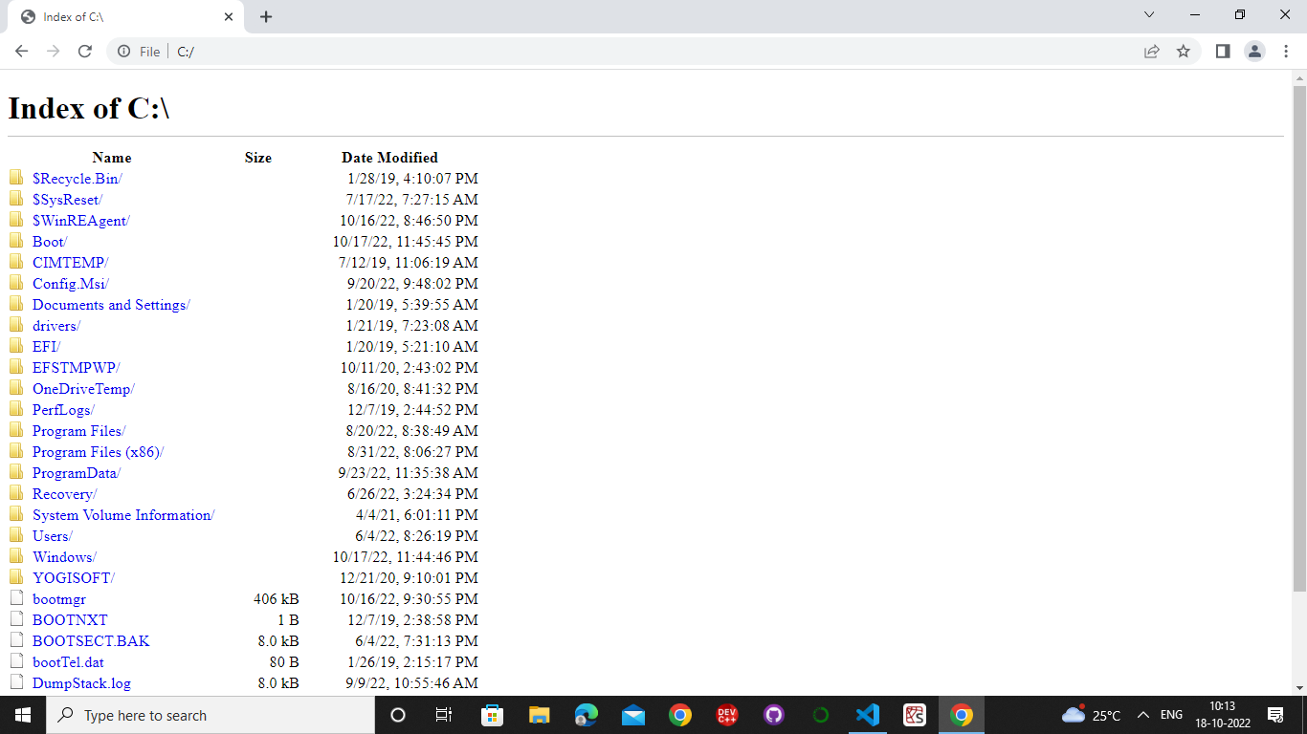

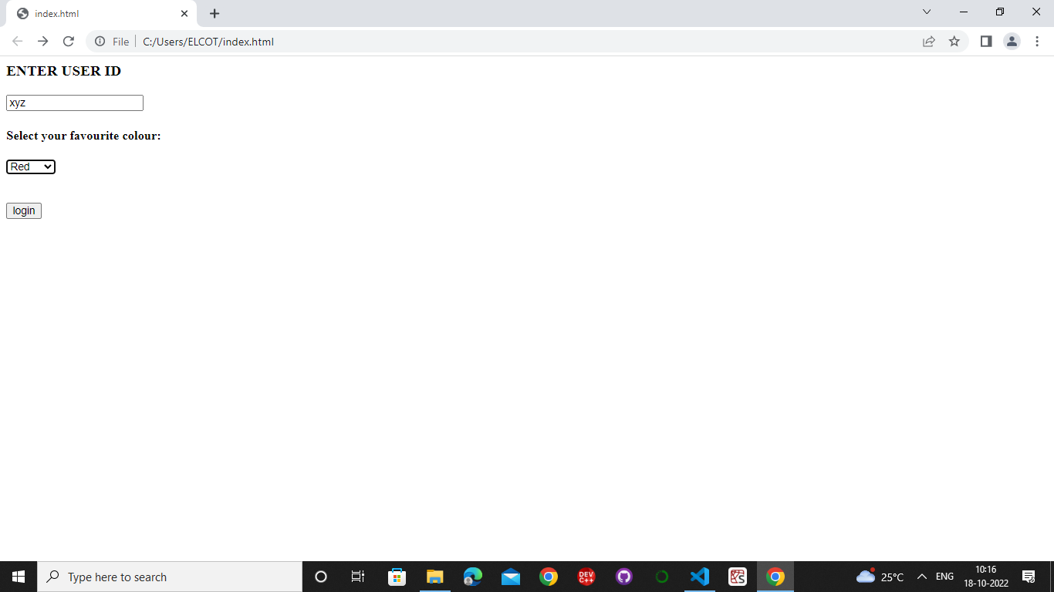

**Question-3:**

Write a flask program which should display resume details and also have resume options by using file uploading.

|  |
| --- |
| **Solution:** |

**HTML CODE**

<html lang="en">

<head>

<meta charset="UTF-8">

<meta http-equiv="X-UA-Compatible" content="IE=edge">

<meta name="viewport"

content="width=device-width, initial-scale=1.0">

<link rel="stylesheet" href="style.css">

</head>

<body>

<div class="full">

<div class="left">

<div class="image">

<img src=ibm.jpg alt="ibm"

style="width:100px;height:100px;">

</div>

<div class="Contact">

<h2>Contact</h2>

<p><b>Email id:</b>xyz@gmail.com</p>

<p><b>Mobile no :</b>1234567890</p>

</div>

<div class="Skills">

<h2>Skills</h2>

<ul>

<li><b>Programming Languages :

Python, Java, C++</b></li>

<li><b>Frontend : HTML5, CSS3,

JavaScript, React</b></li>

<li><b>Backend : Node.js</b></li>

</ul>

</div>

<div class="Language">

<h2>Language</h2>

<ul>

<li>English</li>

<li>Tamil</li>

</ul>

</div>

<div class="Hobbies">

<h2>Hobbies</h2>

<ul>

<li>Reading novels</li>

<li>Dancing</li>

</ul>

</div>

</div>

<div class="right">

<div class="name">

<h1>RESUME</h1>

</div>

<div class="title">

<p>Web Developer</p>

</div>

<div class="Summary">

<h2>Summary</h2>

<p>To secure a challenging position in a

reputable organization

to expand my learning knowledge and skill

</p>

</div>

<div class="Experience">

<h2>Experience</h2>

<h3>Abcwebdevpvt ltd - Senior Web Developer</h3>

<p>January 2022 to Present</p>

<ul>

<li>Actively engaged in web creative

design and development.</li>

<li>Designing project &planing</li>

</ul>

<ul>

<li>Actively engaged in web creative

design and development.</li>

<li>Designing project &planing</li>

<li>Working on designing</li>

</ul>

</div>

<div class="Education">

<h2>Education</h2>

<table>

<tr>

<th>University/college </th>

<th>Passing year </th>

<th>percentage/cgpa</th>

</tr>

<tr>

<td>xyz</td>

<td>2023</td>

<td>8.9</td>

</tr>

<tr>

<td>pqr</td>

<td>2018</td>

<td>89%</td>

</tr>

</table>

</div>

<div class="project">

<ul>

<li>

<h2>Project1</h2>

<p>This project is based on html

&css</p>

</li>

<li>

<h2>Project2</h2>

<p>This project is based on html

&java script</p>

</li>

</ul>

</div>

</div>

</div>

</body>

</html>

**HTML CODE for file uploading**

<!DOCTYPE html>

<html>

<head>

<title>HTML input type file</title>

<style>

h1 {

color: green;

}

h2,

h3 {

font-family: Impact;

}

body {

text-align: center;

}

</style>

</head>

<body>

<h2>RESUME</h2>

<label> Choose the File to upload: </label>

<input type="file" id="myFile" /><br /><br />

<input type="submit" value="submit" />

</body>

</html>

**CSS CODE**

* {

margin: 0;

padding: 0;

box-sizing: border-box;

}

body {

background-color: rgb(253, 254, 255);

display: flex;

justify-content: center;

align-items: center;

}

.full {

width: 50%;

max-width: 1000px;

min-height: 100px;

background-color: rgb(245, 239, 231);

margin: 0px;

display: grid;

grid-template-columns: 2fr 4fr;

}

.left {

position: initial;

background-color: rgb(126, 219, 231);

padding: 20px;

}

.right {

position: initial;

background-color: rgb(162, 202, 206);

padding: 20px;

}

.image, .Contact, .Skills, .Language, .Hobbies, .title,

.Summary, .Experience, .Education, .project {

margin-bottom: 30px;

}

.h2 {

background-color: rgb(4, 96, 150);

}

**FLASK PROGRAM**

from flask import Flask,render_template,request

app=Flask(_name_)

@app.route('/')

def home():

return render_template('resume.html')

@app.route('/Login',methods=["POST"])

def resume():

if request.method=="POST":

user=request.form["nm"]

return render_template("resume.html",y=user)

if _name==('main_'):

app.run(debug=True)

**OUTPUT**

